(In most cases I would expect one sentence for each item. Tell peers what page to find the code for flex/grid, how you are indicating current page, etc.)

**Your name:** Dane Taylor

**Link to your deployed site:** https://taylomd.github.io/portfolio-2021/index.html

**Link to your Github repository:** https://github.com/taylomd/portfolio-2021

1. Do you have at least four pages that are linked via a common navigation bar. Does the page have a common header and footer across all four pages? Does each page have a unique title?

*Nav bar is in the top right corner of the website view and top left of the mobile view. Each page has a unique title and body but they share a common header and footer.*

1. How do you indicate the current page WITHIN the links in the navigation? (Make sure you are not using just color)

*The current page is indicated using a nav class called “current_page”, which highlights the current page using a colored, underlined box.*

1. Is the minimum content present. (Latin filler doesn’t count - it is important to be dealing with real content.) Does one page have at least nine (9) images?

*Each page contains pictures, and my My Work page has 9+ images, most of which are styled with grid.*

1. What elements use grid and which pages are these elements on? How did you use grid differently from the homework? Did you use Inspect Element to check that removing display: grid changes the page? (Include screenshot if desired.)

*The image elements have a grid container on the My Work page. I used grid differently than the homework by displaying them mostly inline and using max-width of 100%. Using inspect element, I checked to see that grid changes the page.*

1. What did you do to make your pages particularly visually appealing? How did you come up with your color scheme? Tell us more about your font choices, image editing, etc. I am sure there are things that you did that we can't easily see. ***Make sure that you checked your site ON A PHONE***. We are looking for how it looks on a small screen.

*I designed the website to reflect the professional portfolio I already have on Adobe Portfolio. By this I mean I used the fonts, styling, and color scheme to portray a professional, clean look that might appeal to recruiters or potential teammates or classmates. I already edited the images in photoshop to reflect my creative skills, and showcase most of the creative works in a grid-like pattern with a few of my favorites at the bottom.*

1. Validation - Include screenshots of your page validating on aXe and Wave. If you have errors that you don’t think should count against your grade include documentation. You only need to show screenshots from two pages, not all four so a total of four screenshots.

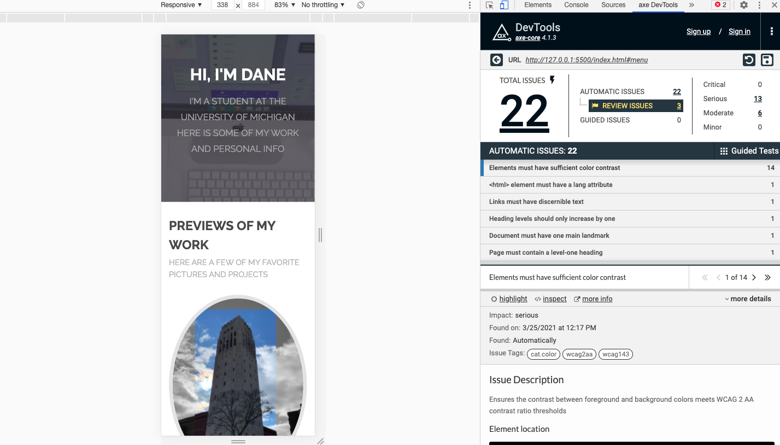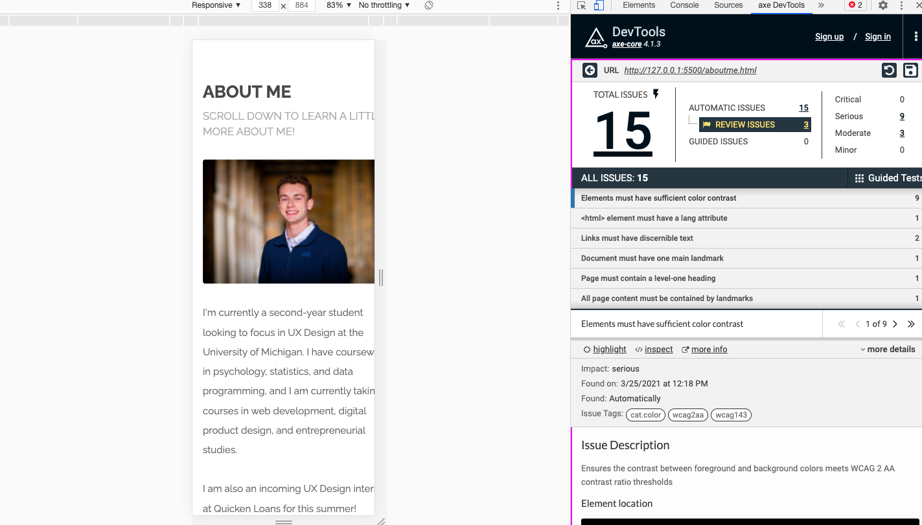

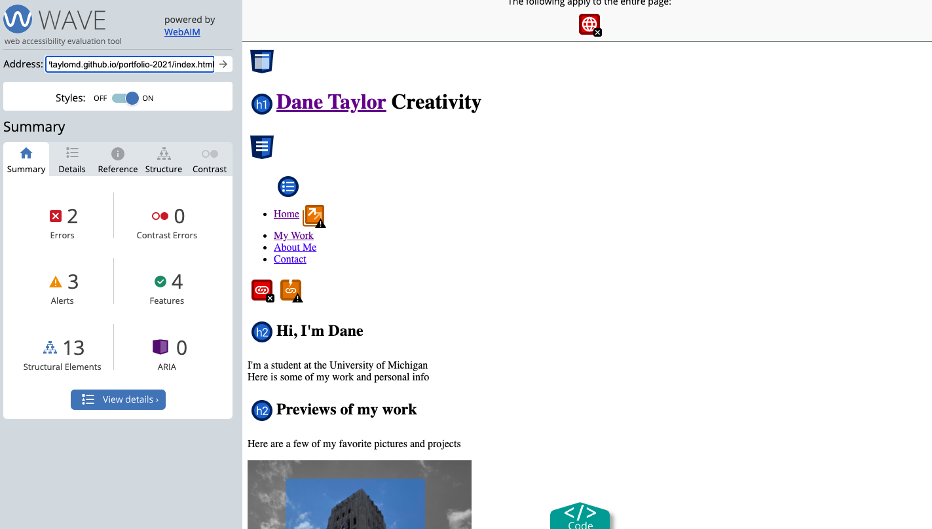

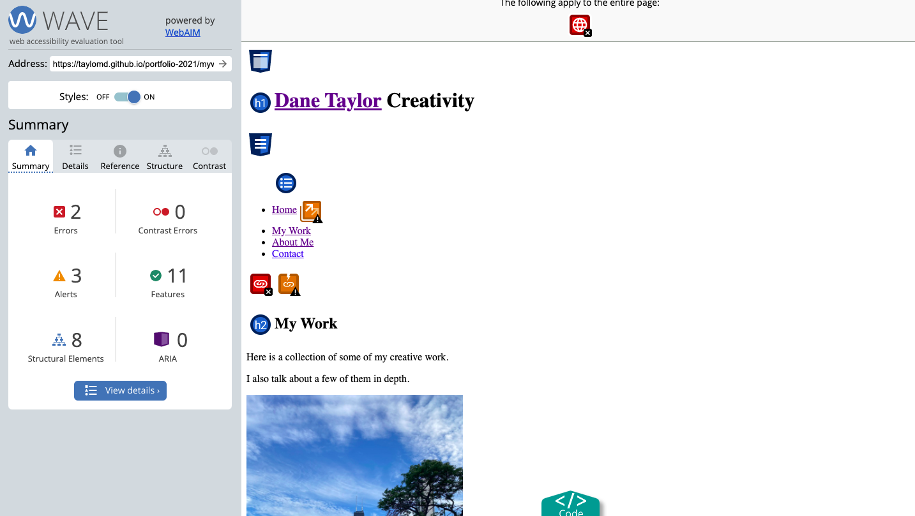

1. Check your site for other issues. Are you using the html5reset style stylesheet? Did you remember to include the viewport meta tag? Do you have console errors? Did you use proper naming conventions (no uppercase letters or spaces, mnemonic file names, etc.)

*Most conventions are taken care of and the viewport meta tag is present. There is no html5reset style stylesheet, because the reset is already embedded in the style.css file along with the main styling for the site.*

When you submit the link to this document in the comments section make sure that you have set the share permissions to allow anyone with the link to view and/or comment.